AM000-Asia-China-Mirror-Han-4 Leaf-16 Arc-4 Boss-2nd c BCE

- 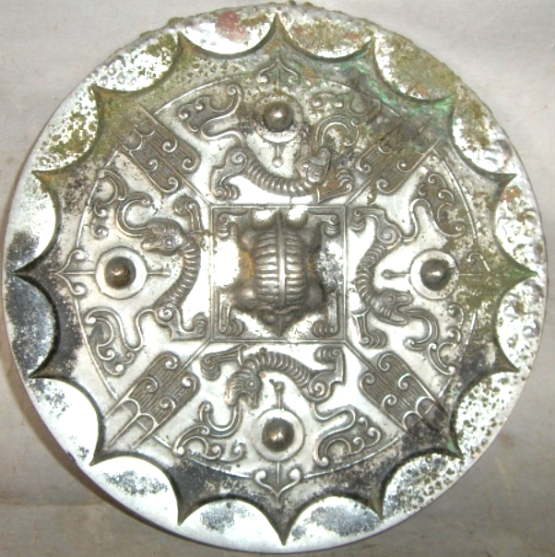

4 Leaf-16 Arc-4 Boss Mirror with 'caoye' design, 2nd century BCE (Karlgren 1941:111)

The 'caoye', or grass and leaf pattern incorporates a symmetrical motif resembling an ear of corn and the trefoil motifs which appear on the main ground of the mirror surrounding the central square. An inscription cast into the square band reads: 'jianri zhiming, tianxia daming' (may you see the light of the sun and may the world enjoy great lightness), suggesting that the design symbolizes cosmological harmony.

Similar to Karlgren (1941, pl. 78, no. 13: "Knob and quatrefoil...; square central band [missing an inscription in our example], at corners of the central band ... brush-like petals; four bosses, under them dragons and above them simple petals." White metal, 16 continuous rim arcs, inner square and 4 leaves (caoye); 4 bosses at the cardinal directions, dragon (?) at the central knob. Four leaf, 16 arc and 4 boss configurations, which appeared at the end of the Warring States period, depict a cosmological scheme: the arcs suggest the sun's cycle, and the bosses indicate the cardinal points of the compass to point the way.

The four designs between the four cardinal bosses have been interpreted as "brush like petals (Karlgren 1941:112), "birds with spread wings" (Swallow (1977:44) and as "a 'caoye', or grass and leaf, pattern ... defined by the symmetrical motif resembling an ear of corn" (Menzies 2003:74). It has also been suggested that the leaf designs may be derived from the Shang taotie 饕餮, all-devouring beast, suggesting that the viewer is being engaged in a mysterious communication with Shang Ti (heaven's order). The taotie motif is actually picked up by dragons that wind around the four cardinal bosses. The central square motif recalls a Ch'in brick according to Swallow (1977:44).

**References**:

Karlgren, Bernard. 1941. Huai and Han. BMFEA, 13. Stockholm.

Menzies, Jacqueline. 2003. "Mirror with 'caoye' design [1[st century BCE](http://www.artgallery.nsw.gov.au/collection/search/?period=china.han-dynasty-206-bce-220-ce)]," The Asian Collections: Art Gallery of ‘The Asian Collections: Art Gallery of New South Wales’, pg.74.

Nakano, T., Ecke, T.Y. and Cahill, S., 1994. Bronze Mirrors from Ancient China: Donald H. Graham, Jr. Collection (Honolulu, 1994).

Swallow, Robert W. 1977. Ancient Chinese bronze mirrors. Rev. and enlarged ed. by Fred Belcher. Ann Arbor: Ars Ceramica, Ltd.

Taipei National Palace Museum. [1986] Gu gong tong jing te zhan tu lu = Catalogue of the special exhibition of bronze mirrors in the National Palace Museum. Taipei: Guo li go gu gong bo wu yuan, Minguo 75.